**Morphometry of Bluegill sunfish (*Lepomis macrochirus*) varies with lake dissolved organic carbon concentration**

Chelsea Bishop1, Madlen Stange1, Stuart E. Jones2, Andrew P. Hendry1, and Christopher T. Solomon3

1 Dept. of Biology, McGill University, Montréal, QC, Canada

2 Dept. of Biological Sciences, University of Notre Dame, Notre Dame, IN, USA

3 Cary Institute of Ecosystem Studies, Millbrook, NY, USA

**Abstract**

Inter- and intra-population trait polymorphisms related to foraging and locomotion in benthic and pelagic habitats have been observed in many fishes. Researchers have found that diet, habitat, visibility, and lake chemical components such as DOC are all associated with how different traits may present within fish species (Bentzen and Mcphail 1984; Ehlinger and Wilson 1988; Drinan *et al.* 2012; Bartels *et al.* 2016; Caves *et al.* 2017). The concentration of dissolved organic carbon (DOC) in the water strongly influences the productivity of benthic and pelagic food chains in lakes , suggesting that DOC might impose selection on these traits and lead to classic benthic-foraging “littoral” forms at low DOC concentrations and pelagic-foraging “limnetic” forms at high DOC concentrations. We tested this hypothesis via geometric morphometric and meristic analyses of body, fin, eye, and gill raker morphometry of Bluegill sunfish (*Lepomis macrochirus*, Centrarchidae) from fourteen lakes with DOC concentrations ranging from 4 to 24 mg L-1. These lakes were in close proximity to each other in northern Wisconsin, straddling the drainage divide between the Mississippi River and Laurentian Great Lakes watersheds. Many of the traits that we considered were significantly related to DOC concentration, and in most cases the sign (though not always the magnitude) of these relationships was consistent across the two watersheds. Fish from lakes with high DOC concentrations tended to have deeper bodies, deeper and shorter caudal peduncles, shorter and shallower heads, and perhaps larger eyes. Their pectoral fins tended to be inserted more anteriorly and perhaps vertically; pectoral fin length also varied with DOC, but the direction of this effect differed between the two watersheds. The gill rakers on the first branchial arch were longer and more widely spaced at high DOC, but the number of gill rakers did not vary with DOC. While many of the traits that we quantified were significantly related to DOC concentration, the directions of these relationships did not match with the predicted littoral-limnetic patterns. This may be because DOC has complex effects on the fitness landscape for foraging and locomotion traits; because high DOC favors a littoral-limentic generalist rather than a limnetic specialist; or because the littoral-limnetic morphometric dichotomy is less clear and universal than is commonly thought.

**Introduction**

Inputs of terrestrially derived dissolved organic matter play an important role in structuring lake food webs (Jones 1992; Thomas 1997; Roulet and Moore 2006; Solomon *et al.* 2015). Lakes located in boreal or forested areas commonly obtain heterotrophic energy in the form of terrestrially derived dissolved organic matter (measured as dissolved organic carbon, DOC) (Vadeboncoeur *et al.* 2001; Ask *et al.* 2009; Finstad *et al.* 2014a; Solomon *et al.* 2015). These inputs include plant materials which accumulate and break down to release various compounds including humic and fulvic acids, giving lakes a distinct ‘tea-stained’ or brown color (Jones 1992; Thomas 1997; Roulet and Moore 2006; Solomon *et al.* 2015). The coloring properties of DOC reduces light penetration and alters the vertical distribution of heat in the water column (Jones 1992; Roulet and Moore 2006). Collectively, these effects have substantial implications for benthic (bottom) and pelagic (open water) food chains, including primary production of algae and secondary production of benthic and planktonic invertebrates (Karlsson *et al.* 2009; Ask *et al.* 2012; Godwin *et al.* 2014; Craig *et al.* 2015)

Benthic primary and secondary production are strongly negatively related to DOC concentration (Karlsson *et al.* 2009; Ask *et al.* 2012; Godwin *et al.* 2014; Craig *et al.* 2015). In the pelagic habitat, the situation is more complex: primary production can be stimulated by intermediate DOC concentrations, though productivity falls off at high concentrations – and pelagic secondary production seems to follow the same pattern (Kelly *et al.* 2014, 2016, 2018; Batt *et al.* 2015; Carpenter *et al.* 2016; St-Gelais *et al.* 2017; Bergström and Karlsson 2019). Thus, benthic production is strongly negatively related, and pelagic production often positively related until concentrations exceed 15 mg/L, to DOC. These effects of DOC at the base of benthic and pelagic food chains can propagate up to influence the productivity of fishes, which often link those food chains via their mobile foraging behaviors (Vander-Zanden and Vadeboncoeur 2002; Karlsson *et al.* 2009; Finstad *et al.* 2014b; Craig *et al.* 2015; Benoît *et al.* 2016; Koizumi *et al.* 2018).

DOC concentrations can differ substantially among lakes, even those in close proximity to one another. Differences in watershed area, terrestrial vegetation, hydrologic flow paths, lake volume, and other factors create heterogeneity in the delivery of terrestrial organic matter to lakes, its processing within lakes, and thus in the concentrations of DOC (Canham *et al.* 2004; Jones *et al.* 2018). Although the DOC concentration of a given lake can vary at multiple time scales (Hessen *et al.* 1997; Schindler *et al.* 1997; Pace and Cole 2002), substantial differences between lakes are fairly stable over long time periods in the absence of major anthropogenic disturbances (Monteith *et al.* 2007; Meyer-Jacob *et al.* 2019). Such spatial heterogeneity – even at a small scale (Richardson *et al.* 2014) – sets the stage for natural selection or phenotypic plasticity to generate adaptive variation among populations (Hendry 2017).Yet we are aware of only two studies that have considered whether fish phenotypes are related to DOC concentrations. First, Bartels et al. (2016), examining Eurasian Perch in lakes with DOC concentrations between 4 and 34 mg L-1, found that increasing DOC concentration was associated with longer heads, larger eyes, and more narrow caudal peduncles. They go on to show, using stable isotope analysis, a greater reliance on pelagic resources in high DOC lakes (Bartels et al. 2016). Second, Craig et al. (2017), examining Bluegill sunfish in lakes with DOC concentrations between 3 and 24 mg L-1, found that populations in lakes with high DOC had low initial growth rate, late maturity, and low lifetime fecundity, whereas these traits showed more variation among low-DOC lakes.

Given that DOC concentrations control the productivity of benthic and pelagic food chains, and differ substantially and stably between lakes, we propose they will shape divergence in the traits of fishes that forage on either benthic or pelagic prey. Trait polymorphisms linked to the different demands of benthic and pelagic foraging have been observed in a number of fish species (Schluter and McPhail 1993; Robinson and Wilson 1994; Smith and Skúlason 1996). Pelagic specialists tend to have fusiform bodies, shorter pectoral fins, and pectoral fin insertions that are more anteriorly placed and horizontally angled; all traits suited to cruising and sustained swimming rather than maneuvering among vegetation and in complex shoreline habitats. They also tend to have longer, more numerous, and more closely spaced gill rakers suited to capturing small zooplankton – as opposed to larger zoobenthos. These environment-trait associations have been observed in many fish groups including gasterosteids, centrarchids (including Bluegill), and percids (Mcphail 1984; Ehlinger and Wilson 1988; Schluter and McPhail 1993; Smith and Skúlason 1996; Svanbäck and Eklöv 2002). These benthic versus pelagic trait differences typically reflect a mixture of genetic differences (evolution) and environmental influences (plasticity).

Our proposal is that differences in DOC between lakes that influence the relative profitability of benthic versus pelagic foraging will generate shifts in the traits that so often diverge between pelagic and benthic specialists. Hence, we here investigate the relationship between lake DOC concentrations and the morphometry of Bluegill (*Lepomis macrochirus*, Centrarchidae). Bluegill are among the most common and widespread freshwater fishes in North America; they exhibit morphometric and behavioral polymorphisms linked to tradeoffs between benthic and pelagic foraging, as well as diverse life history strategies (Dominey 1980; Gross and Charnov 1980; Mittelbach 1981; Gross 1991; Belk 1995; Aday *et al.* 2003). We sampled Bluegill from a set of lakes in northern Wisconsin, USA, varying in DOC concentration from 4 to 24 mg L-1 and straddling the drainage divide between the Great Lakes and Mississippi River watersheds. We hypothesized that the morphometry of Bluegill would be consistent with a greater reliance on zooplanktivory, and lower reliance on benthivory, in high-DOC lakes. Specifically, we expected that DOC concentration would be positively associated with fusiform body shape, shorter and narrower pectoral fins, anteriorly positioned and horizontally angled pectoral fin insertion, longer and more numerous gill rakers with smaller inter-raker spacing, and larger eyes.

**Methods**

*Study Design and Sampling*

We conducted morphometric analyses on Bluegill sampled from 14 lakes with DOC concentrations between 4 and 24 mg L-1 (Table 1). All of the lakes were within a radius of ~40 km, near the Wisconsin-Michigan border, USA. This is a low-relief, lake-rich glacial region that straddles the divide between the Great Lakes and Mississippi River drainages. Phylogeographic work using mitochondrial DNA sequences from Bluegill collected to the south and east of our study site does not indicate deeply rooted phylogenetic diversity in this region (Kawamura et al. 2009 Zool. Sci.). Nonetheless we chose study lakes such that our sample size and distribution of DOC concentrations would be approximately equal in the two drainages, thus preventing potential proximity confoundment between DOC and lineage/drainage.

We sampled ~30 Bluegill individuals from each lake between June and August 2018, using a variety of methods including fyke nets, boat electrofishing, and angling (Table 1). Fyke nets (12 m lead, 1.3 cm bar mesh, 1 m3 car, four hoops and two throats) were set from afternoon to morning, with the lead line set perpendicular to the shore. Electrofishing was conducted at night using alternating current. Angling was conducted near sunrise or sunset using standard tackle. Captured fish between 75 and 150 mm total length (or longer when necessary) were euthanized by overdose of buffered MS-222. We suspended euthanized fish from a rack by the tail before freezing them, a procedure that reduced bending and thus facilitated later geometric morphometric analysis. Animal care procedures were approved under protocol #2016-06.

All data and code for our analyses are publicly available (Solomon *et al.* 2018) (Solomon et al. 2018; <GitHub page>).

**Table 1**. Summary of lake characteristics and sampling for survey lakes. DOC is the mean dissolved organic carbon concentration.

|  |  |  |  |  |  |  |  |  |
| --- | --- | --- | --- | --- | --- | --- | --- | --- |
| Lake | Latitude | Longitude | Area (ha) | Max depth (m) | DOC (mg/L) | Watershed | No. Fish collected | Capture method(s) used* |
| Bay | 46.24418 | -89.49733 | 67.3 | 12.2 | 7.4 | Great Lakes | 30 | FN, A |
| Birch | 46.21767 | -89.83838 | 204.8 | 13.7 | 10.9 | Mississippi | 29 | FN, E |
| Crampton | 46.20965 | -89.47368 | 25.9 | 18.5 | 5 | Great Lakes | 30 | FN |
| Found | 45.95051 | -89.45320 | 136 | 6.4 | 6.2 | Mississippi | 30 | E |
| Hummingbird | 46.24368 | -89.50587 | 0.8 | 7.6 | 24.5 | Great Lakes | 30 | FN, A |
| Little Crooked | 46.15085 | -89.69511 | 62 | 9.1 | 4.1 | Mississippi | 30 | E |
| Lost | 45.96554 | -89.48312 | 218.1 | 6.1 | 4.0 | Mississippi | 30 | FN, E |
| McCullough | 46.19831 | -89.57043 | 89.4 | 8.2 | 14.3 | Great Lakes | 30 | FN |
| Muskellunge | 45.95180 | -89.37989 | 109.3 | 5.8 | 6.7 | Mississippi | 30 | E |
| Oxbow | 46.19967 | -89.49964 | 212 | 13.4 | 11.1 | Great Lakes | 30 | FN, E |
| Papoose | 46.18476 | -89.80266 | 171 | 19.8 | 6.5 | Mississippi | 30 | FN |
| Red Bass | 46.19825 | -89.66405 | 10.9 | 6.7 | 18.9 | Great Lakes | 30 | FN |
| Squaw | 45.88447 | -89.99458 | 298 | 6.4 | 23.9 | Mississippi | 28 | FN |
| Towanda | 45.93854 | -89.70771 | 56.3 | 8.2 | 5.3 | Mississippi | 30 | FN, E |

**\*FN= fyke-net, A= angling, E= electrofishing.**

*Morphometrics and Meristics*

Digital photographs were taken under consistent lighting with a Nikon D300 camera on a tripod, with the F-stop and ISO set to 15 and 200 respectively. We photographed the left side of the body after thawing the specimen, pinning its fins so that fin insertion points were clear, ensuring that its mouth was closed, and including a scale reference. We separately calculated eye width as the distance between landmarks #2 and #19, and angle of pectoral fin insertion from landmarks #13 and #14 (Figure 1A) After photographing each specimen, we removed the right pectoral fin and preserved it in 95% ethanol. Later, we spread and pinned each fin and photographed it using the procedure described above for body photos. We examined the gill rakers from the left anterior-most gill arch, which we dissected from the buccal cavity. We counted the rakers under a dissecting microscope, and then took a photo of the gill arch to measure raker length and spacing. We took photos using a Leica microscope with DMC camera attachment connected via USB to a computer with Leica software. A scale reference was included in each photograph. Following Robinson et al. (1993), we measured the length of the four rakers that follow the apex raker located at the crown of the arch (Figure 1C). For each, we measured raker length as a straight line from the insertion point in the arch to the distal point of the raker, and raker spacing as a straight line along the base of arch from the posterior edge of one raker to the anterior edge of the next (Figure 1C). These measurements were made using the measurement tool included in the tpsDig2 v.2.31 program (Rohlf, 2006).

We quantified body morphometry of each specimen from the full body photographs by digitizing 19 true type II two-dimensional landmarks using tpsDig2 v.2.31 (Rohlf & Bookstein 1990, Rohlf 2006) (Figure 1A). To assess digitizing error, a subset of 60 specimens underwent four landmarking procedure replications. We then conducted a Procrustes ANOVA of these replicates and found that inter-individual variation was significantly greater (F=187.18, P=0.001) than inter-replicate variation (F=2.6012, P=0.001) and replicate accuracy was calculated as 95%. Due to the high repeatability we measured the remaining specimens only once. Pectoral fin morphometry was also examined using the same landmarking procedures and four true type landmarks were digitized onto the images (Rohlf, 2006) (Figure 1B). Due to high variability in how far the fin could be spread apart we could not place a replicable landmark along the ventral side. This limitation prevented us from obtaining a pectoral fin width measurement, and so we instead measured the fin insertion width as the distance between landmarks #13 and #14 and fin length as the distance between landmarks #14 and #21 (Figure 1B). Following Robinson et al. (1996), we calculated pectoral fin aspect ratio as the width of the insertion point of the fin divided by its total length. We separately calculated the angle of pectoral fin insertion from landmarks #13 and #14 of the full body photos and eye width as the distance between landmarks #2 and #19 (Figure 1A).

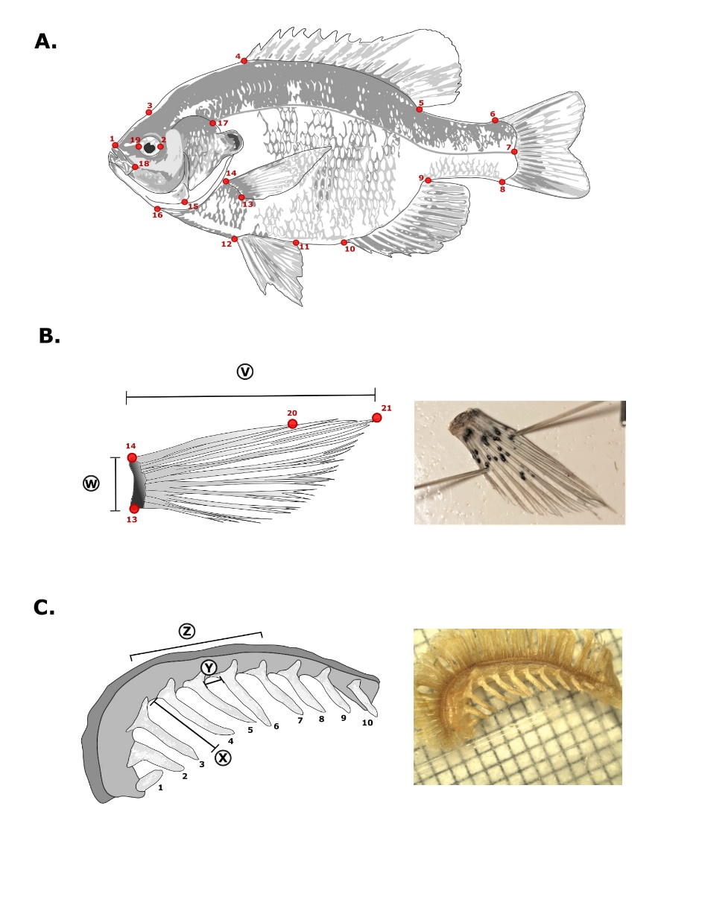

**Figure 1.** Landmark positions and meristic measurements for Bluegill sunfish**. A.** Full body landmark positions**. 1.** Dorsal tip of premaxillary. **2**. Right-centered edge of eye. **3.** Forehead above center of eye. **4**. Dorsal fin anterior insertion point. **5**. Dorsal fin posterior insertion point. **6**. Caudal fin dorsal insertion point. **7**. Caudal fin mid insertion point intersecting with lateral line end point. **8**. Caudal fin ventral insertion point. **9**. Anal fin posterior insertion point**. 10**. Anal fin anterior insertion point. **11**. Pelvic fin posterior insertion point. **12**. Pelvic fin anterior insertion point. **13**. Pectoral fin ventral insertion point. **14**. Pectoral fin dorsal insertion point**. 15.** Intersection point between suboperculum and interoperculum**. 16.** Anterior intersection point between isthmus and gill structures. **17**. Intersection point between lateral line and operculum. **18.** Dorsal, posterior tip of maxillary. **19**. Left-centered edge of eye. **B.** Pectoral fin landmarks and measurements. **20**. Tip of first dorsal ray. **21**. Tip of third/longest ray. **V**. Fin length measurement. **W**. Fin base width measurement. **C**. Gill arch with raker measurements. **X**. Raker length measurement. **Y**. Raker spacing measurement. **Z**. Rakers 4-7 and spaces between them were those used in analyses.

*Statistical Analyses*

We conducted geometric morphometrics analyses using the geomorph v.3.1.0 package in R v.3.5.3 (Adams et al. 2019, R Core Team 2019). We subjected raw coordinates to a generalized Procrustes analysis (Zelditch *et al.* 2004) to remove isometric size effects and achieve uniform orientation. We then conducted a principal components analysis to identify the major axes of shape variance among all the Bluegill in our sample. To visualize morphospace based on shape along the first two principal components, we created a backtransform morphospace (Olsen, 2017) (Figure 2).

We evaluated the relationship between DOC and body shape by using the random residual permutation procedure with 1000 iterations within the geomorph package (Add in package and other references Collyer and Adams, 2019). Using the procD.lm function we subjected the shape data to a four-factor multivariate analysis of covariance with (Add in procD.lm references). Centroid size was included as a covariate, DOC and watershed as fixed effects, and lake as a random effect. Centroid size, a of proxy for fish size calculated from the 2D shape data, is the square root of the sum of squared distances of all landmarks from their centroid, which is obtained by averaging landmark *x* and *y* coordinates (Klingenberg, 2016). We want to test the impact of the co-variate (centroid size) on shape to eventually remove the variance in shape that is explained by the co-variate (Zelditch *et al.* 2004). We determined interactions between the covariate and multiple factors (DOC, lake, and watershed) thus preventing us from being able to remove the variation by regression (Zelditch *et al.* 2004). Instead, the focus of our analysis must be on the interactions between the factors and the covariate rather than the main effects of the factors (Zelditch *et al.* 2004). To analyze other phenotypic traits, including eye width and characteristics of pectoral fins and gill rakers, we used univariate models similar in structure to the model described above for the shape data, including DOC and watershed as fixed effects and lake as a random effect. Most of these traits covaried with fish size (standard length), so we size standardized using the equation given in Kaeuffer et al. (2012). We fit these models using R packages lme4 and lmerTest (Bates et al., 2015, Brockhoff & Christensen, 2017).

**Results**

The first two principal components of the overall body shape data explained 52% of the individual-level variation in shape and 80% of the lake-level variation. The first principal component described a shift from a longer, fusiform body to a shorter, deeper one, including from a long and narrow caudal peduncle to a short deep one; from a longer to shorter eye diameter; from a more horizontal to a more vertical insertion of the pectoral fin (Figure 2). The second principal component described a shift from a smaller head and more anteriorly positioned pectoral fin to a larger head and more posteriorly positioned pectoral fin (Figure 2).

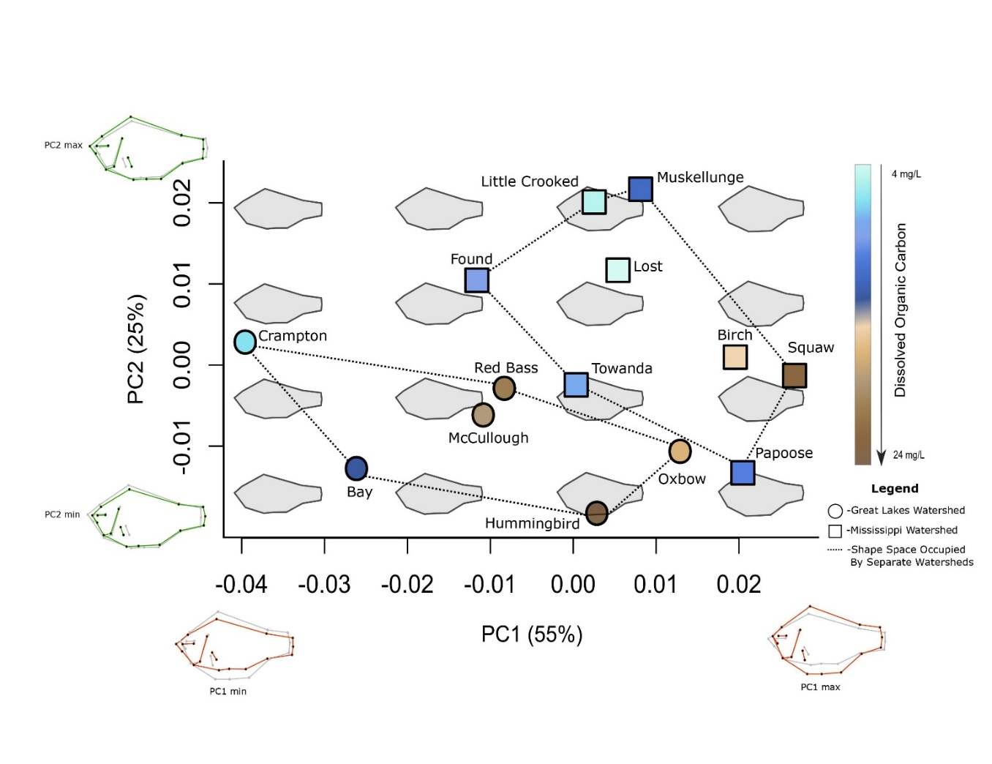

**Figure 2.** Variation in Bluegill shape across lakes is related to dissolved organic carbon (DOC) concentration. Points indicate the mean fish shape from each lake; point shape indicates the watershed in which the lake is located, and point color indicates its DOC concentration. Fish shapes are plotted in the background for reference. PC1 is positively correlated with shorter, deeper body shape, a more vertical pectoral fin insertion angle and a smaller eye diameter. PC2 is positively correlated with head size and a more posterior pectoral fin position.

Body shape of Bluegill was significantly related to DOC concentration (Table 2, Fig. 2). There was also a significant difference in shape between the Great Lakes and Mississippi watersheds, and a variable allometric effect on shape (Table 2). Lakes with DOC concentrations < 10 mg L-1 occupied almost the entire morphospace, whereas lakes with DOC concentrations > 10 mg L-1 were associated with positive PC1 values and negative PC2 values. Although average shapes of Great Lakes watershed and Mississippi watershed Bluegill were different; in both watersheds, the gradient from low to high DOC was associated with higher PC1 values and lower PC2 values – that is, with deeper bodies, shorter and smaller heads, wider eyes, and pectoral fin insertions that were more anteriorly and vertically positioned. There were 14 outlier fish shapes, of which 7 came from Crampton Lake.

**Table 2**. Multivariate analysis of covariance for Bluegill shape data. Significant results are bold. “Csize” is centroid size, a measure of fish size.

|  |  |  |  |  |  |  |  |
| --- | --- | --- | --- | --- | --- | --- | --- |
|  | **Df** | **SS** | **MS** | **Rsq** | **F** | **Z** | **Pr(>F)** |
| Csize | 1 | 0.04901 | 0.07900 | 59.0470 | 59.0470 | 9.5052 | **0.0010** |
| DOC | 1 | 0.01140 | 0.01837 | 13.7332 | 13.7332 | 6.5652 | **0.0010** |
| Watershed | 1 | 0.02795 | 0.04505 | 33.6748 | 33.6748 | 8.2264 | **0.0010** |
| Lake | 11 | 0.09654 | 0.15564 | 1.0000 | 1.0000 |  | 0.5005 |
| Csize:Watershed | 1 | 0.00076 | 0.00122 | 0.9111 | 0.9111 | -0.0270 | 0.5070 |
| Csize:DOC | 1 | 0.00250 | 0.00403 | 3.0153 | 3.0153 | 2.9277 | **0.0020** |
| Csize:Watershed:DOC | 1 | 0.00172 | 0.00277 | 2.0683 | 2.0683 | 2.0417 | **0.0220** |
| Residuals | 399 | 0.33115 | 0.000830 | 0.53383 |  |  |  |
| Total | 416 | 0.62032 |  |  |  |  |  |

Bluegill fin length was significantly related to DOC and watershed (Table S1, Fig. 3). Pectoral fin length increased with DOC concentration for lakes within the Great Lakes watershed, whereas the opposite was observed for the Mississippi watershed (p<0.05; Table S1, Fig. 3A). Neither DOC concentration nor watershed influenced pectoral fin base width, aspect ratio, or insertion angle, although a trend towards wider fin bases was suggestive in the Great Lakes watershed (Table S1, Fig. 3B-D). Although a change in pectoral fin insertion angle was apparent in the shape data along PC1 (Fig. 2), insertion angle was not directly associated with DOC or watershed (Table S1, Fig. 3D).

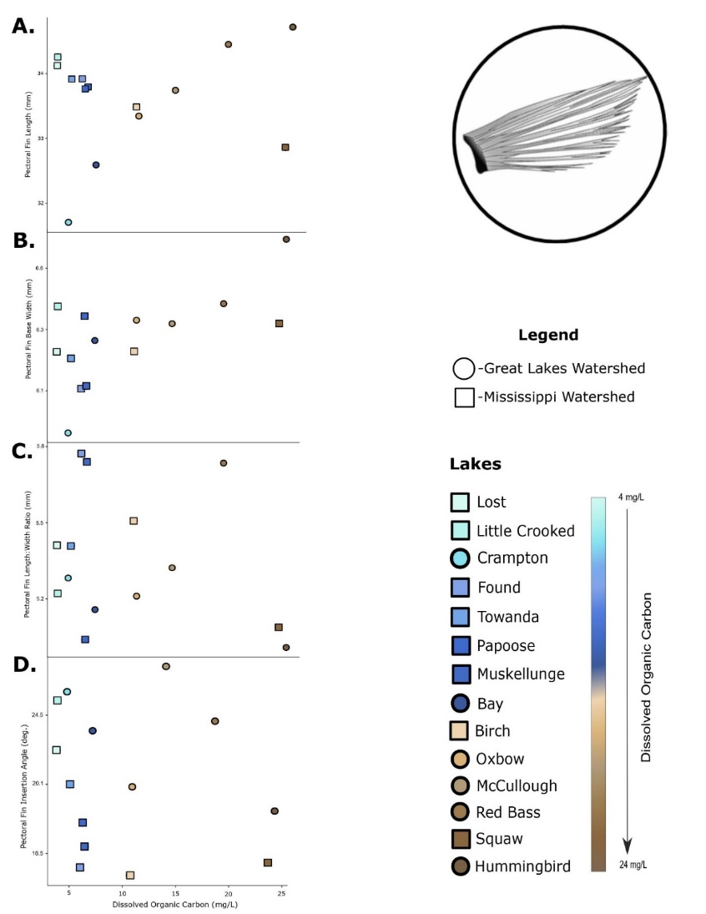

**Figure 3**. Variation in pectoral fin traits across DOC concentrations within two different watersheds. Points indicate the size-corrected, mean fitted values for each lake. **A**. Pectoral fin length. **B**. Pectoral fin width at base. **C**. Pectoral fin aspect ratio. **D**. Pectoral fin angle of insertion.

Gill raker length and inter-raker spacing were significantly related to DOC concentration and watershed (Table S2, Fig. 4). Raker length was positively related with DOC and was greater in the Mississippi River watershed (p<0.05; Table S2, Fig. 4A). Raker spacing was also positively related to DOC concentration; the slope of this relationship was less steep for lakes in the Mississippi River watershed than for those in the Great Lakes watershed (p<0.05; Table S2, Fig. 4B). The number of rakers on the gill arch ranged from 9 to 15 and was strongly related to fish size, but not to DOC concentration (p=0.7; Table S2, Fig. 4C). Finally, eye width was not significantly related to DOC concentration and did not differ by watershed (p=0.9, Table S3, Fig. 5).

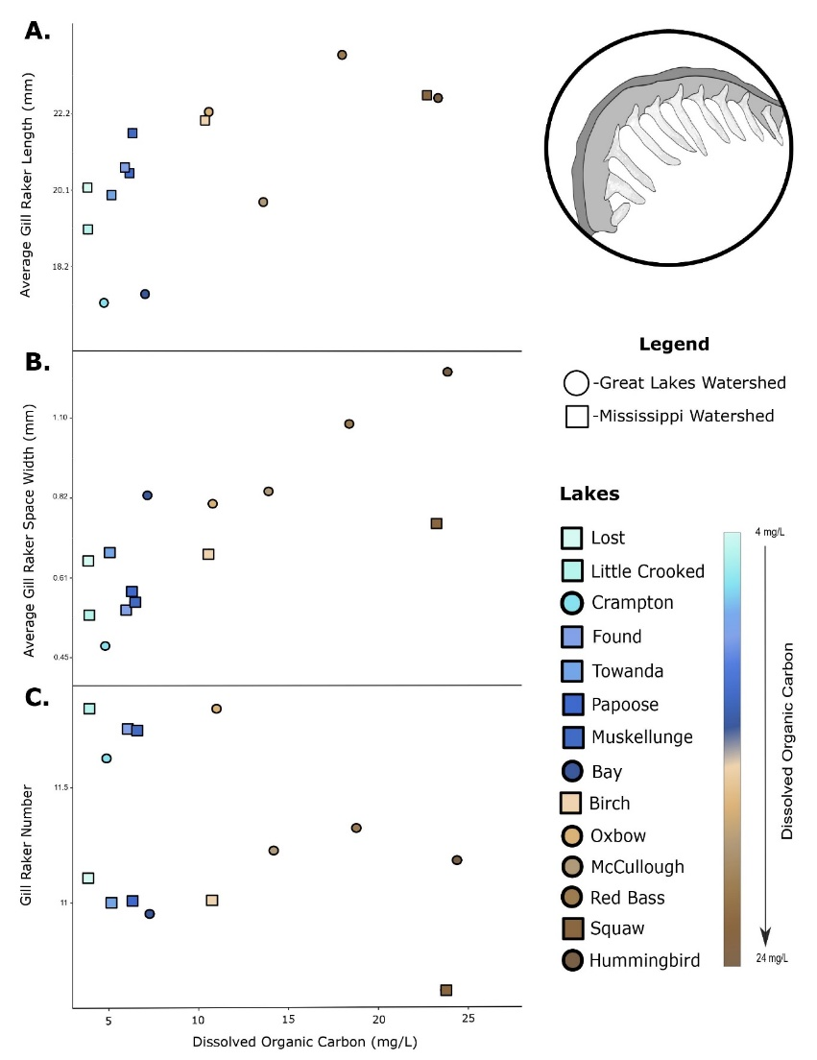

**Figure 4.** Variation in gill raker traits along the DOC gradient across two watersheds. Points indicate the size-corrected, mean fitted value for each lake. **A**. Gill raker length. **B**. Gill raker spacing. **C**. Gill raker number.

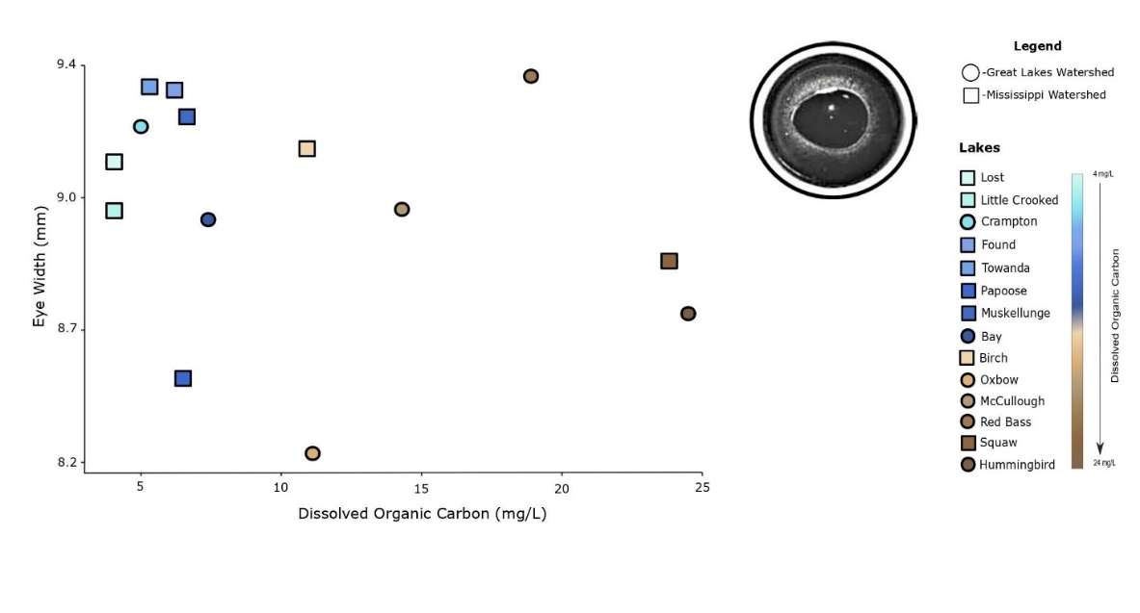

**Figure 5.** Variation in eye widths along the DOC gradient across two watersheds. Points indicate the size-corrected, mean fitted value for each lake.

**Table 3.** Summary of the expected and observed relationships between fish morphometry and lake dissolved organic carbon concentration (DOC). *Expectation* is the expected relationship. *Opposing evidence* highlights studies that counter the expectation. *Observed (morphospace)* is the trend that we observed in the multivariate analysis of external morphometry (Fig. 2). In this column, and the next one, **bold** indicates that the observation matched the expectation, while *italics* indicate that the observation showed the reverse of the expected pattern. Traits not considered in a given analysis are indicated with a dash (-). *Observed (univariate)* summarizes the result of a univariate test of significance of the relationship between the trait and DOC concentration. In all columns, table entries indicate the morphometry associated with high-DOC lakes; for instance, body shape was expected to be more fusiform in high-DOC lakes (and therefore less fusiform, or more deep, in low-DOC lakes).

|  |  |  |  |  |
| --- | --- | --- | --- | --- |
| **Trait** | **Expectation** | **Opposing evidence** | **Observed**  **(morphospace)** | **Observed**  **(univariate)** |
| Body shape | fusiform2, 4, 7 | no relationship5* | *deep* | - |
| Caudal peduncle depth | shallow1, 8 | no relationship5* | *deep* | - |
| Caudal peduncle length | long5, 7 |  | *short* | - |
| Head length | long1, 3 | 5* | *short* | - |
| Head depth | shallow3 |  | **shallow** | - |
| Eye size | large1, 3 |  | **large** | no relationship |
| Pectoral fin insertion point | anterior2 |  | **anterior** | - |
| Pectoral fin insertion angle |  | no relationship5 | vertical | no relationship |
| Pectoral fin length | long5 | short2, 7 | - | **long**; *short\*\** |
| Pectoral fin width | narrow |  | no relationship | no relationship |
| Gill raker length | long6 |  | - | **long** |
| Gill raker spacing | narrow4 | no relationship5* | - | *wide* |
| Gill raker number | more4 | no relationship5* | - | no relationship |

* This study examined littoral and pelagic forms of pumpkinseed in a lake without Bluegill. Pelagic fish had (non-significant) shallower bodies and caudal peduncles. There was no difference in number of gill rakers or gill raker length, but rakers were wider and angled differently in pelagic form, such that they overlapped more. Head length measured as predorsal length was shorter in pelagic fish; for other measures of head length there was a significant interaction between habitat (benthic or pelagic) and fish size.

** Pectoral fin lengths were longer at high DOC in the Great Lakes watershed, but shorter at high DOC in the Mississippi River watershed.

**Discussion**

We observed morphological differences in Bluegill across the DOC gradient, which were largely consistent across the two major watersheds from which we sampled. Yet these differences did not neatly match our expectation of classically “benthic” traits at low DOC versus “pelagic” traits at high DOC. Instead, we observed a mixture of expected, unexpected, and null relationships between DOC concentration and the traits we examined (Table 3). We can see at least two plausible explanations for these surprising results, which we consider below along with some additional points.

As a first step, it is useful to recognize that the null relationships we observed in X, Y (Table 3) probably provide evidence that DOC does not impose strong selection on these traits in Bluegill. An alternative interpretation is that DOC does impose selection on these traits but that they lack the genetic or plastic potential to respond to that selection. This second possibility does not seem likely, because studies with Pumpkinseed, a congener of Bluegill, show that most of the traits in question can have rapid plastic and/or genetic responses when fish are reared in littoral versus open water enclosures (Robinson and Wilson 1996, Yavno and Fox 2014). Hence, it seems more reasonable to conclude that DOC does not impose selection on these traits, or at least not strongly enough for us to detect it. Yet another possibility is that genetic and plastic effects offset each other, as in “counter-gradient variation” (Conover and Schultz 1995; Conover et al. 2009). RegardlessAccordingly, any logically consistent explanation for the results that we observed should accommodate the null relationships with DOC as well as the significant ones.

Such an explanation might be that selection imposed by DOC concentration does not map neatly on to the classic littoral/limnetic axis of traits. Certainly, strong evidence exists that DOC influences the productivity of benthic and pelagic food chains, as we described in the Introduction. Yet these ecosystem-level metrics might not adequately describe the effects of DOC on either the benefits or the costs of benthic and pelagic foraging strategies, which depend on the ability to efficiently find and ingest prey while avoiding predators. For instance, the availability of zoobenthos to foraging Bluegill might be less sensitive to DOC than is total zoobenthos production, because high DOC seems to limit total zoobenthos production largely by limiting the range of depths over which substantial production occurs; at shallow depths, zoobenthos production can be similar in low- and high-DOC lakes (Craig et al. 2015). At the same time, DOC might also influence the rate at which Bluegill can locate their prey or be located by potential predators. Thus, highHigh DOC concentrations might reduce the ability of fish to see zooplankton and thus the rate at which they can consume them, or interfere with the ability of zooplankton to detect chemical cues of fish presence and make a behavioral avoidance response (Estlander et al. 2010, Estalander et al. 2012, Jönsson et al. 2012, Weidel et al. 2017, Santonja et al. 2017). High DOC might also reduce the ability of piscivorous fishes to locate their prey, which could alter the predation risks that Bluegill smaller than the gape limit of the piscivore face while foraging in benthic or pelagic habitats (Ranaker et al. 2012). The unexpected trait associations that we observed – such as the trend towards deeper bodies but longer gill rakers in high DOC lakes – might reflect the net effect that DOC (or potentially other factors that covary with DOC) has on the benefits and costs of benthic and pelagic foraging strategies. Future work to more carefully quantify how the benefits and costs of different foraging strategies vary across a DOC gradient would be a useful step forward from the results that we present here.

A related possibility is that high DOC concentrations might favor generalist foragers, rather than pelagic specialists as we had hypothesized. Werner and Hall (1974) developed and tested a model for the optimal diet breadth of a fish – using Bluegill as a model – foraging on prey of different sizes available at different densities. They considered only different size classes of *Daphnia* zooplankton as prey, allowing variation in handling time to be ignored. In the model, search time varies among prey items because their size is linked to the distance from which they are visible. When search times overall are long – because of low prey density, poor visual conditions in the water, or low fish activity, for instance – then broader diets are favored. Interestingly, all three of these contributors to long search times might occur in high-DOC lakes, because prey densities might be low and high DOC reduces light availability and mean water column temperature (cites). Two features of our results provide at least some support for the idea that we see generalists at high DOC. First, the mix of traits that observe in high DOC lakes does not match either of the classic limnetic or littoral morphotypes, but instead seems like a mixture of the two (Table 3). Second, the morphometries of fish from high DOC lakes tended to be fairly similar, whereas there was more divergence in morphometry among low-DOC lakes (Fig. 2). Limited pilot data on Bluegill diets in two of our study lakes (n=28 to 91 fish per lake, mean total length ~ 75 mm) also provide some support for this idea: in Crampton Lake (5.0 mg DOC L-1) fish were benthic specialists, consuming 69% benthic prey and 11% pelagic prey by mass, whereas in Hummingbird Lake (24.5 mg DOC L-1) fish consumed 45% benthic and 50% pelagic prey.

A second, distinct explanation for our resultsresults is that while the availability of benthic and pelagic prey does change with DOC in the way we had assumed, the link between benthic or pelagic foraging behavior and fish morphometry is not as strong or consistent as we had assumed, at least at an intra-species level. Certainly, there are iconic examples of littoral and limnetic morphotypes of several fish species (cites). On the other hand, exceptions exist to the expected patterns (Table 3). Passt studies investigating *Lepomis* sunfish (Bluegill or Pumpkinseed) morphometric responses? provide evidence both for and against a relationship, and in some cases for relationships in opposite directions. For instance, a study of Bluegill in a single lake observed that fish collected from deep water had shorter pectoral fins than those collected from shallow vegetated habitats, while a study of Pumpkinseed collected from similar habitats in another lake observed the opposite pattern (Ehlinger and Wilson 1988, Robinson et al. 1993).

<Other ideas that could be touched on in Discussion:>

* Our results demonstrating differences in morphometry between the Great Lakes and Mississippi drainages maybe suggest the possibility that these may be different lineages? The Kawamura paper doesn’t suggest this possibility, but they didn’t have any samples available from our study region – closest were in southern WI and in lower peninsula of Michigan.
* Robinson et al. 1993 say “Bluegill have an average of 20 rakers on the first branchial arch compared to 11 for pumpkinseeds (Smith, 1985; Moyle and Cech, 1988)”. But we see ~ 11 in our Bluegill (from anterior-most gill arch – same thing as “first”?). Is this surprising? What does it mean?
* Talk about whether eye size is a good indicator of visual acuity?

<Wrap-up paragraph>